**Lab Report: 1**



**System Programming Lab**

**Fall 2022**

**Submitted by:**

**Maaz Habib**

**Registration no.:**

**20PWCSE1952**

“On my honor, as a student of University of Engineering and Technology Peshawar, I have neither nor received unauthorized assistance on this academic work”

**Submitted to:**

**Eng. Abdullah Hamid**

1. **Read the man pages for the following commands (write man [command] on terminal, press q to exit man):** 
   1. **script**
   2. **finger, who, w**
   3. **touch**
   4. **top**
   5. **mkdir**
   6. **umask: umask [value] (shell built in command)**
   7. **text utilities: sort, uniq, tr, expand, unexpand, cut.**
   8. **gcc**
   9. **history**
   10. **grep**
   11. **awk**
   12. **Ps**
   13. **Echo**
2. **Script and finger:**

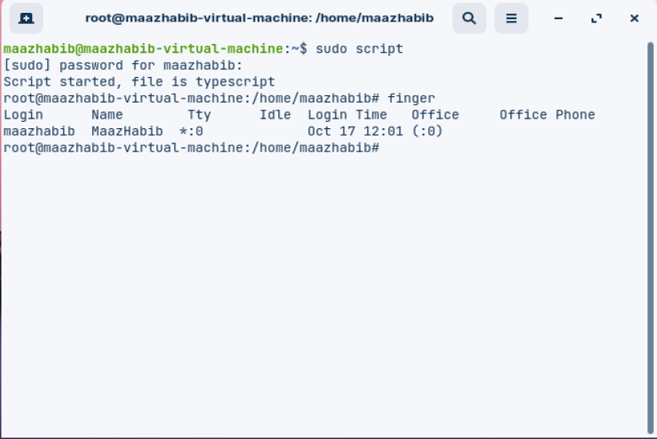

1. **Who:**

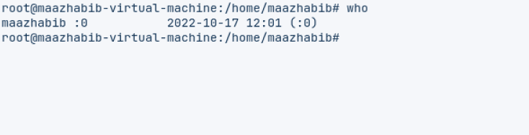

1. **w:**

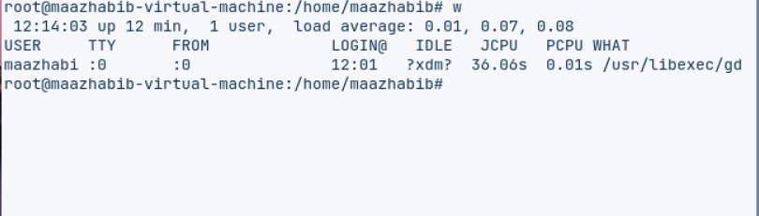

1. **touch:**

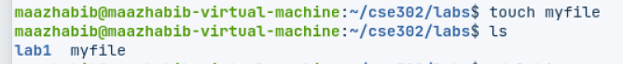

1. **top:**

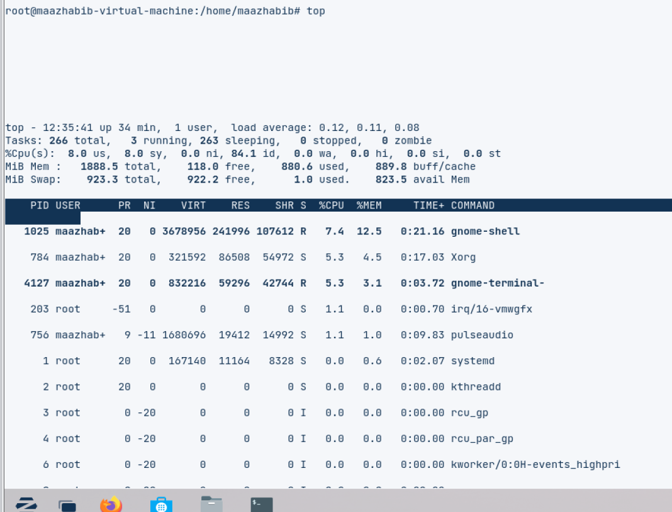

1. **mkdir:**

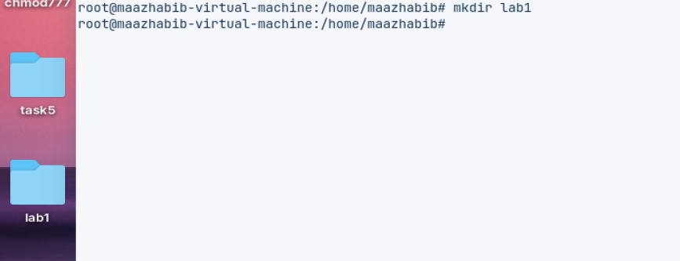

1. **umask: umask [value] (shell built in command)**

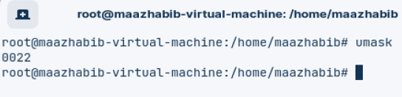

1. **text utilities:**

* **sort:**

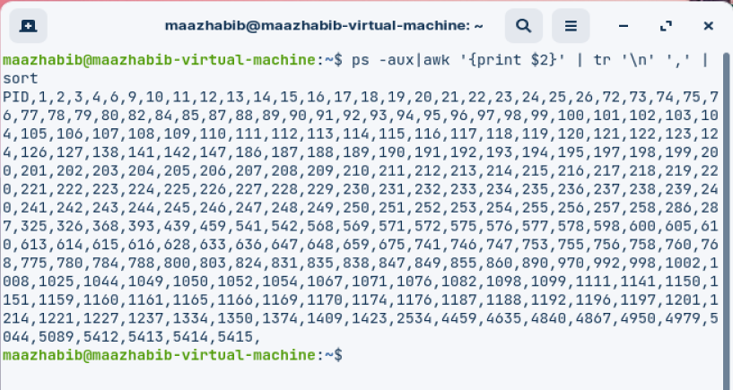

* **uniq:**

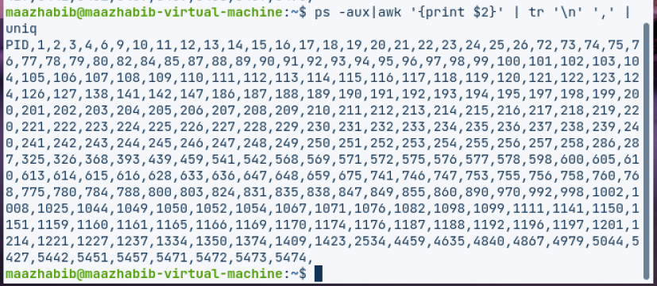

* **expand:**

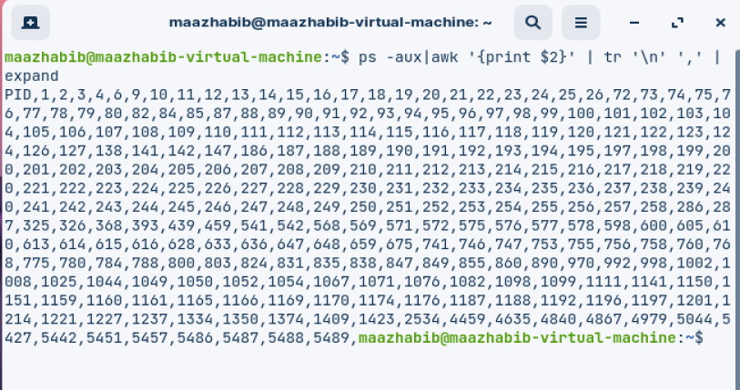

* **unexpand:**

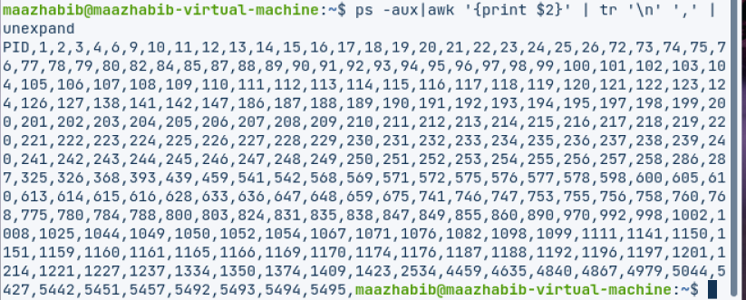

1. **Gcc:**

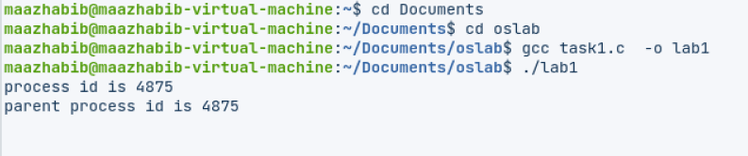

1. **history:**

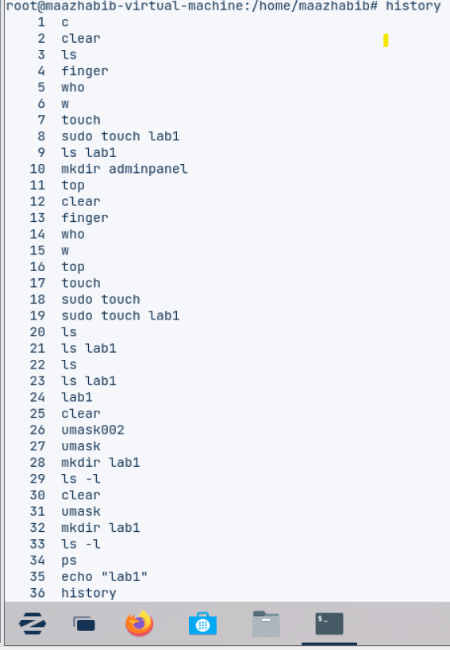

1. **grep:**

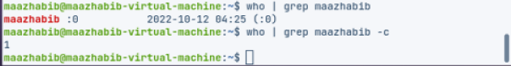

1. **awk:**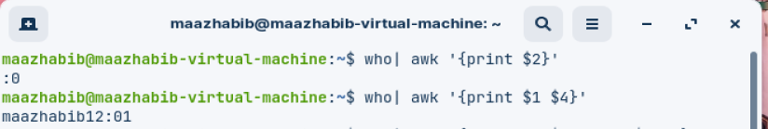
2. **Ps:**

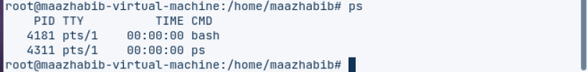

1. **Echo:**



**Question:2 In your home directory create the subdirectory ~/cse302/labs/lab1. (Use multiple mkdir commands or consult the -p option for mkdir in the man page for mkdir).**

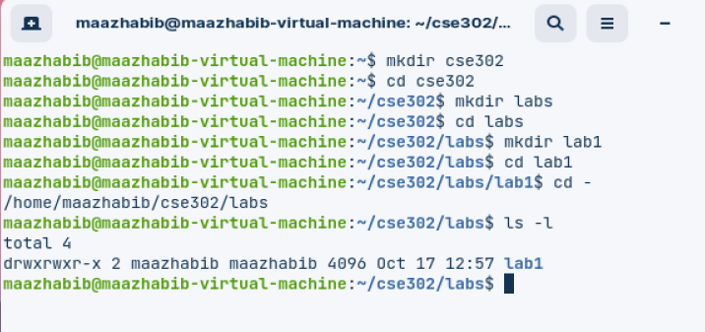

* 1. cd ~/cse302/labs/lab1
  2. Copy or create a file named **myfile** into ~/cse302/labs/lab1 (if you create it, type something into it).  For information on how to create a quick empty file, man touch. 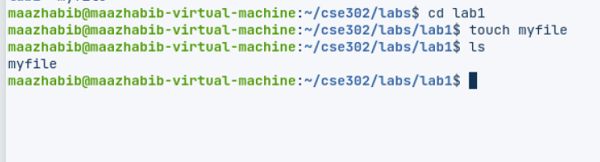

1. Create a soft link **soft_link** and a hard link **hard_link** to that file.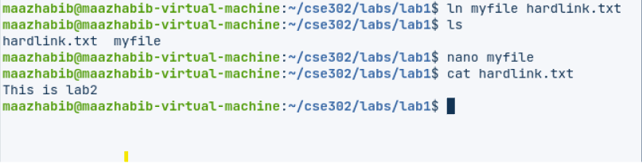
2. Based on the output returned by stat and ls commands (using all relevant options), explain in detail (but briefly) the differences between the three files.

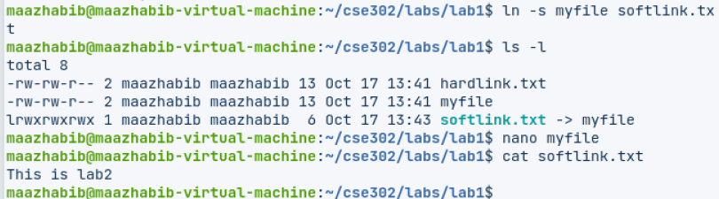

**Question3.Create a script and show how many usernames have logged in use pipelining, grep and who command also investigate wc in man.**

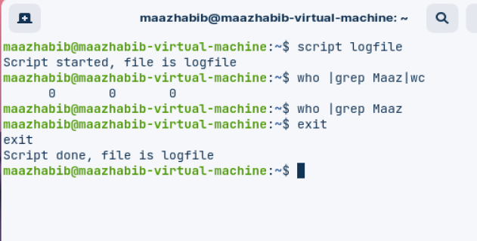

**Question:4**

**Change your file permission mask such that by default your colleagues do not have read permissions for your newly created files. Please show in the transcript file the following:**

* + 1. **The initial mask**
    2. **How you changed it**
    3. **Show that people in your user group don't have read permissions for a new file you're creating.  
       Change the umask permanently by placing the umask ... command in your .bash_profile file.**

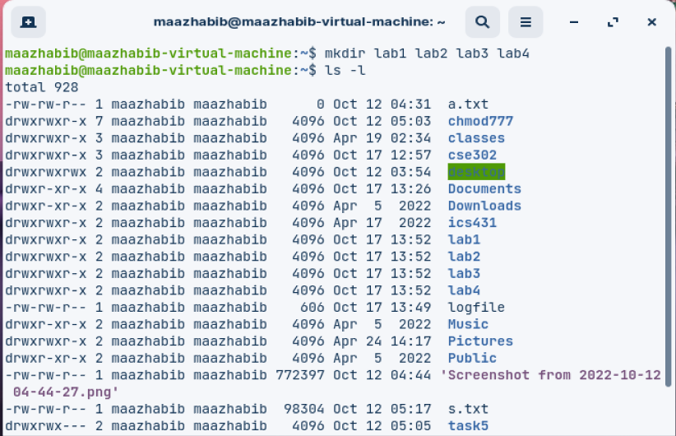

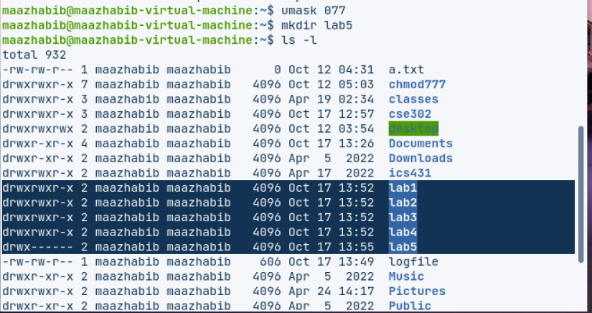

**Question:5**

**List the PIDs of all processes running as root on your computer on a line, separated by commas. E.g., 1,2,3,4,5,657,658, ... Use pipes to create a one-line command that accomplishes this. You'll need some of the text processing tools presented in class. Hint: man ps (-a and -x flags), man tr.**



**Question:6**

**List the usernames and names of the people logged on the list returned should be sorted and should have the following format:**

**1 <username1> <Time>  
2 <username2> <Time>  
3 <username3> <Time>  
...**

**Hint: use the "nl" command to number lines.**

